**Question: A population has a standard deviation of 25 and a mean of 300. Given a random sample of size 100, how likely is it that the sample mean will be within +/- 5 of the population mean?**

**SOLUTION: We seek to know as to What is the probability that the sample mean will be within +/- 5 of the population mean (to 4 decimals)?**

**A standard normal variate is defined as:**

$$z=\frac{\overline{x}-μ}{σ}$$

**where $\overline{x} is the given random variable$**

$$μ=Population mean$$

**and $σ is the population standard deviation$**

**Therefore,**

**z(295) = (295-300)/25 = -0.2 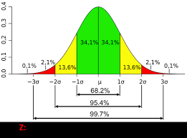 z(305) = (305-300)/25 = +0.2  
P(295 < z < 305) = p(-0.2 < z < 0.2) = 0.1586**

**Hence is the probability that the sample mean will be within +/- 5 of the population mean (to 4 decimals) is 0.1586.**